### ALGORITHM:

**STEP 1:** Start

**STEP 2:** Declare variables

**STEP 3:** Enter the password and username.

#### if password and username match, then,

**STEP 3.1** Display the menu as:

* + 1. Enter the patient details
    2. Enter the Hospital details
    3. Display the bloodgroup details
    4. Display the patient details
    5. Display the hospital
    6. Display all data

**STEP 3.2** Enter the choice:

if ch==1, then

Enter the details of patient as: patient id

patient bed number patient name patient blood group

no. of blood required patient gender

patient phone number patient disease

**STEP 3.3** if you want to continue

Go to **STEP 3.1**

else

Go to **STEP 4**

**STEP 3.4** if ch==2,then

Enter the details of hospital as: Hospital id

Hospital name Hospital address

**STEP 3.5** You want to continue

Go to **STEP 3.1**

else

Go to **STEP 4**

**STEP 3.6** if ch==3,then

Display the details of bloodgroup as: Bloodgroup name

Stock

**STEP 3.7** If **y**ou want to continue

Go to **STEP 3.1**

else

Go to **STEP 4**

**STEP 3.8** if ch==4,then

Display the patient details

**STEP 3.9** You want to continue

Go to **STEP 3.1**

else

Go to **STEP 4**

**STEP 3.10** if ch==5,then

Display the hospital details

**STEP 3.11** if you want to continue

Go to **STEP 3.1**

else

Go to **STEP4**

**STEP 3.12** if ch==6,then

Display all the details of

1. Bloodgroups
2. Patient
3. Hospital

**STEP 3.13** if you want to continue

Go to **step 3.1**

else

Go to **STEP 4**

#### ELSE

**Display “Invalid password and username”**

**STEP 4**: End.

**FLOWCHART:**

**START**

DECLARE VARIABLES

EENnTtEerRUUsSerEnRamNeA&ME & **P**AasSsSwWorOdRD

DECLARE VARIABLES

if U.name, NO

Password

matches

Display the Menu

YES

Print Invalid Username & Password

Enter the Choice Between 1 to 7

if ch==1

if ch==2

if ch==3

if ch==4

if ch==5

if ch==6

Enter Patient details

Enter Hospital details

Display Blood G. details

Display Patient details

Display Hospital details

Display all details



if ch==7

If you want to contintue

NO

STOP

YE

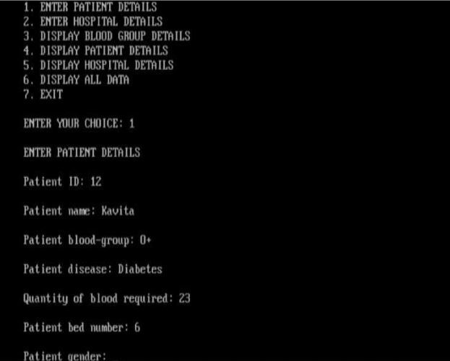

### Username and Password are entered.



**Menu is displayed and choice is Entered. According to choice, After Pressing 1 [Patient Details are entered…]**

### After Pressing Y, [if we want to continue, Menu is displayed…]



**After Pressing 4, [Patient details are displayed… ]**

